**Chapter-4 (Practice Questions Lecture-11**

1. Simplify the following Boolean expression to a minimum number of literals.
2. X’Y’ + XY + X’Y
3. X’Y’Z + X’YZ + XY’
4. XY +X’Z + YZ
5. A’B(D’+C’D) +B(A+A’CD)
6. (A’+C)(A’+C’)(A+B+C’D)
7. (X’Y’ +Z)’ + Z + XY + WZ
8. A’C(A’BD)’ + A’BC’D’ + AB’C
9. AB(C+C’) +AC
10. Apply DeMorgan’s theorems to each expression:

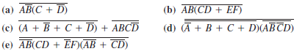

( f) (AB+CD)’ + (EF)’ (g) A{(B+C’)’D}’

1. [(M+N’)(M’+N)]’
2. Apply DeMorgan’s theorems to each expression:

